Extended Essay Quick Guidelines Reminders
- the use of 12-point, readable font (Times New Roman, Arial, or Helvetica)
- double spacing
- page numbering (upper right corner in the header)
- no candidate or school name on the title page or page headers
- Word count on title page (The upper limit is 4,000 words for all extended essays)
- Please note: Examiners are instructed not to read or assess any material in excess of the word limit. This means that essays containing more than 4,000 words will be compromised across all assessment criteria. Students who write in excess of the word limit will self-penalize across all criteria. Any knowledge and understanding demonstrated beyond the 4,000-word limit will be treated as if it were not present. Supervisors and students should be aware that the e-upload of extended essays will facilitate the automatic recognition of a cut-off point for assessment. Students should ensure that they remain within the word limit and should edit accordingly.
- Please refer to the following guidance on what content should be included in the word count.
Included in the word count | Not included in the word count
The introduction | The contents page
 | Abstract (final copy – do not worry about it now)
The main body | Maps, charts, diagrams, annotated illustrations
The conclusion | Tables
Quotations | Equations, formulas and calculations
Footnotes and/or endnotes that are not references (we do not do this so it isn’t an issue). | Citations/references (whether parenthetical, numbered, footnotes)
 | The bibliography
.

Illustrations (if used)
Presentation and overall neatness are important, and it is essential that illustrative material, if included, is well set out and used effectively. Graphs, diagrams, tables and maps are effective only if they are clearly labelled and can be interpreted with ease.
Any labelling should contain the minimum information to ensure the examiner understands the significance of the map, chart, diagram or illustration. It must not include commentary, as this will be considered as part of the essay discussion and thus included in the word count.
All such material that is incorporated into the extended essay must be directly related to the text and acknowledged where appropriate. The use of photographs and other images is acceptable only if they are captioned and/or annotated and are used to illustrate a specific point made in the extended essay. Students should be advised to use illustrations with caution as excessive use may detract from the discussion in the essay. They should only be used if they are relevant and appropriate to a point being made as part of the argument of the essay.

Tables
The use of tables should be considered carefully and are only really appropriate in certain subjects. Tables must not be used in an attempt to circumvent the word limit.

Footnotes and endnotes
Footnotes and endnotes may be used for referencing purposes (citing sources) and if this is the case will not be included in the word count of the essay. In order to avoid confusion and unwittingly exceed the word limit, students are advised to avoid using footnotes or endnotes other than for referencing purposes.
As footnotes and endnotes are not an essential part of the extended essay students must take care to ensure that all information with direct relevance to the analysis, discussion and evaluation of their essay is contained in the main body of it.
An essay that attempts to evade the word limit by including important material in footnotes or endnotes will be compromised across the assessment criteria. Please note that footnotes and endnotes are added to the word count as they are encountered.

Appendices
Appendices are not an essential part of the extended essay and examiners will not read them, or use any information contained within them, in the assessment of the essay. Students must take care to ensure that all information with direct relevance to the analysis, discussion and evaluation of their essay is contained in the main body of it. Appendices should therefore be avoided except in the following instances:
- an exemplar of a questionnaire or interview questions
- an exemplar of permission letters
- group 1, category 1 essays: copies of poems or short stories (of less than three pages)
- language acquisition, category 1 and 2: excerpts from newspapers, advertisements, transcripts of speeches, etc.
- language acquisition, category 3: excerpts or copies of poems or short stories (less than 3 pages)
- an external mentor letter, where one has been used (Sciences using off site facilities)
- raw data or statistical tables for experimental sciences (this should not include any analysis or conclusions)
Students should not continually refer to material presented in an appendix as this may disrupt the continuity of the essay and examiners are not required to refer to them.

Specimen materials (Group 4 Experiments)
Specimen materials used in, or produced by, investigations do not form part of the extended essay and must not be submitted. Photographic evidence may be submitted in place of such material.

Academic Misconduct
Research practices when working on an extended essay must reflect the principles of academic honesty. The essay must provide the reader with the precise sources of quotations, ideas and points of view through accurate citations, which may be in-text or footnotes, and full references listed in the bibliography.
Producing accurate references and a bibliography is a skill that students should be seeking to refine as part of the extended essay writing process. Documenting the research in this way is vital: it allows readers to evaluate the evidence for themselves, and it shows the student’s understanding of the importance of the sources used.
Failure to comply with this requirement will be viewed as academic misconduct and will, therefore, be treated as a potential breach of IB regulations.

Order of presentation:
Required elements of the extended essay:
- Title page
- Contents page
- Introduction
- Body of the essay
- Conclusion
- Bibliography
- Appendix (if applicable)

Title page (see template on website and copy with your information)
The title page should include only the following information:
- the title of the essay (centered)
- (double space below title and single space) the research question
- (double space below research question) the subject (i.e. History) for which the essay is registered (if it is a Group 1 or 2 essay also state which category it falls into)
- (double space below) word count

AN IMPORTANT NOTE:
Please note that name of the student or the school should not appear on the title page or on any page headers. This is because the work is assessed anonymously.

Use the formal subject name. Ask your supervisor if you are not sure.

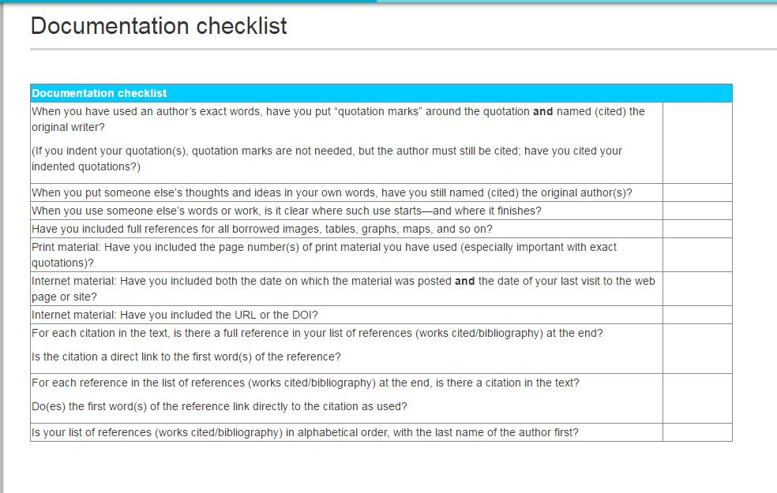
This is a quick checklist and is in NO WAY to be a substitute for following what is expected for MLA, APA, or CMS. Go to the Purdue Owl website for more guidance and details. You do not need to turn this in; it only serves as a reminder.

