MLA Tables, Figures, and Examples
The purpose of visual materials or other illustrations is to enhance the audience's understanding of information in the document and/or awareness of a topic. Writers can embed several types of visuals using most basic word processing software: diagrams, musical scores, photographs, or, for documents that will be read electronically, audio/video applications.

General guidelines
- Collect sources. Gather the source information required for MLA documentation for the source medium of the illustration (e.g. print, Web, podcast).
- Determine what types of illustrations best suit your purpose. Consider the purpose of each illustration, how it contributes to the purpose of the document and the reader's understanding, and whether or not the audience will be able to view and/or understand the illustration easily.
- Use illustrations of the best quality. Avoid blurry, pixilated, or distorted images for both print and electronic documents. Often pixelation and distortion occurs when writers manipulate image sizes. Keep images in their original sizes or use photo editing software to modify them. Reproduce distorted graphs, tables, or diagrams with spreadsheet or publishing software, but be sure to include all source information. Always represent the original source information faithfully and avoid unethical practices of false representation or manipulation.
- Use illustrations sparingly. Decide what items can best improve the document's ability to augment readers' understanding of the information, appreciation for the subject, and/or illustration of the main points. Do not provide illustrations for illustrations' sake. Scrutinize illustrations for how potentially informative or persuasive they can be.
- Do not use illustrations to boost page length. In the case of student papers, instructors often do not count the space taken up by visual aids toward the required page length of the document. Remember that texts explain, while illustrations enhance. Illustrations cannot carry the entire weight of the document.

Labels, captions, and source information
Illustrations appear directly embedded in the document, except in the case of manuscripts that are being prepared for publication. (For preparing manuscripts with visual materials for publication, see Note on Manuscripts below.) Each illustration must include a label, a number, a caption and/or source information.
- The illustration label and number should always appear in two places: the document main text (e.g. see fig. 1) and near the illustration itself (Fig. 1).
- Captions provide titles or explanatory notes.
- Source information documentation will always depend upon the medium of the source illustration. If you provide source information with all of your illustrations, you do not need to provide this information on the Works Cited page.

Source information and note form
For source information, MLA lists sources in note form. These entries appear much like standard MLA bibliographic entries with a few exceptions:
- Author names are in First_Name—Last_Name format.
- Commas are substituted for periods (except in the case of the period that ends the entry).
- Publication information for books (publisher, year) appears in parentheses.
- Relevant page numbers follow the publication information.
Note: Use semicolons to denote entry sections when long series of commas make these sections difficult to ascertain as being like or separate. (See examples below.) The MLA Handbook 8th edition states that if the table or illustration caption provides complete citation information about the source and the source is not cited in the text, authors do not need to list the source in the Works Cited list.

Examples - Documenting source information in "Note form"
Book
Tom Shachtman, Absolute Zero and the Conquest of Cold, Houghton Mifflin, 1999, p. 35.
Website (using semicolons to group like information together)
United States; Dept. of Commerce; Census Bureau; Manufacturing, Mining, and Construction Statistics; Housing Units Authorized by Building Permits; US Dept. of Commerce, 5 Feb. 2008; table 1a.
In this example, the commas in Manufacturing, Mining, and Construction Statistics prompt the need for semicolons in order for the series information to be read easily. Even if Manufacturing, Mining, and Construction Statistics had not appeared in the entry, the multiple "author names" of United States, Dept. of Commerce, and Census Bureau would have necessitated the use of a semicolon before and after the title and between ensuing sections to the end of the entry.
Furthermore, the publisher and date in a standard entry are separated by a comma and belong together; thus, their inclusion here (US Dept. of Commerce, 5 Feb. 2008) also necessitates the semicolons.

MLA documentation for tables, figures, and examples
MLA provides three designations for document illustrations: tables, figures, and examples (see specific sections below).
Tables
- Refer to the table and its corresponding numeral in-text. Do not capitalize the word table. This is typically done in parentheses (e.g. "(see table 2)").
- Situate the table near the text to which it relates.
- Align the table flush-left to the margin.
- Label the table Table and provide its corresponding Arabic numeral. No punctuation is necessary after the label and number (see example below).
- On the next line, provide a caption for the table, most often the table title. Use standard capitalization rules.
- Place the table below the caption, flush-left, making sure to maintain basic MLA style formatting (e.g. one-inch margins).
- Below the title, signal the source information with the descriptor "Source," followed by a colon, then provide the correct MLA bibliographic information for the source in note form (see instructions and examples above). Use a hanging indent for lines after the first. If you provide source information with your illustrations, you do not need to provide this information on the Works Cited page.
- If additional caption information or explanatory notes is necessary, use lowercase letters formatted in superscript in the caption information or table. Below the source information, indent, provide a corresponding lowercase letter (not in superscript), a space, and the note.
- Labels, captions, and notes are double-spaced.
Table Example
In-text reference:
In 1985, women aged 65 and older were 59% more likely than men of the same age to reside in a nursing home, and though 11,700 less women of that age group were enrolled in 1999, men over the same time period ranged from 30,000 to 39,000 persons while women accounted for 49,000 to 61,500 (see table 1).
Table reference:
Table 1
Rate of nursing home residence among people age 65 or older,
by sex and age group, 1985, 1995, 1997, 1999ª
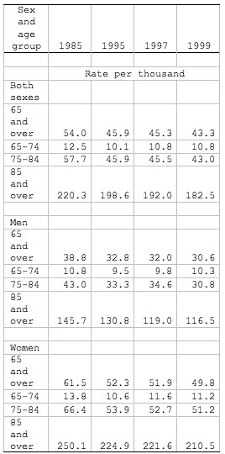
Source: Federal Interagency Forum on Aging-Related Statistics,
Older Americans 2008: Key Indicators of Well-Being,
Federal Interagency Forum on Aging-Related
Statistics, Mar. 2008, table 35A.
a. Note: Rates for 65 and over category are age-adjusted using the 2000 standard population. Beginning in 1997, population figures are adjusted for net under enumeration using the 1990 National Population Adjustment Matrix from the U.S. Census Bureau. People residing in personal care or domiciliary care homes are excluded from the numerator.
Figures
- All visuals/illustrations that are not tables or musical score examples (e.g. maps, diagrams, charts, videos, podcasts, etc.) are labeled Figure or Fig.
- Refer to the figure in-text and provide an Arabic numeral that corresponds to the figure. Do not capitalize figure or fig.
- MLA does not specify alignment requirements for figures; thus, these images may be embedded as the reader sees fit. However, continue to follow basic MLA Style formatting (e.g. one-inch margins).
- Below the figure, provide a label name and its corresponding Arabic numeral (no bold or italics), followed by a period (e.g. Fig. 1.). Here, Figure and Fig. are capitalized.
- Beginning with the same line as the label and number provide a title and/or caption as well as relevant source information in note form (see instructions and examples above). If you provide source information with your illustrations, you do not need to provide this information on the Works Cited page.
Figures Example
In-text reference:
Some readers found Harry’s final battle with Voldemort a disappointment, and recently, the podcast, MuggleCast debated the subject (see fig. 2).
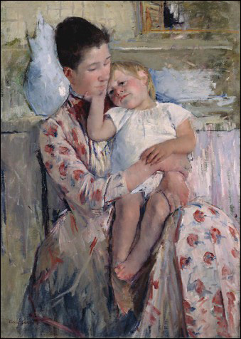
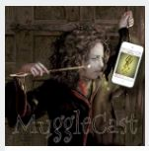
Fig. 1. Mary Cassatt, Mother and Child, Wichita Art Museum. Illus. in Novelene Ross, Toward an American Identity: Selections from the Wichita Art Museum Collection of American Art
(Wichita, Kansas: Wichita Art Museum, 1997) p. 107.
Fig. 2. The final battle. Source- Harry Potter and
Voldemort final battle debate from Andrew Sims
et al.; “Show 166”; MuggleCast; MuggleNet.com,
19 Dec. 2008, www.mugglenet.com/2015/11/
the-snape-debate-rowling-speaks-out.

Figure caption (below an embedded podcast file
for a document to be viewed electronically)

Examples
- The descriptor Example only refers to musical illustrations (e.g. portions of a musical score). Example is often abbreviated Ex.
- Refer to the example in-text and provide an Arabic numeral that corresponds to the example. Do not capitalize example or ex.
- Supply the illustration, making sure to maintain basic MLA Style formatting (e.g. one-inch margins).
- Below the example, provide the label (capitalized Example or Ex.) and number and a caption or title. The caption or title will often take the form of source information along with an explanation, for example, of what part of the score is being illustrated. If you provide source information with your illustrations, you do not need to provide this information on the Works Cited page.

