English Language A: language and literature—example A
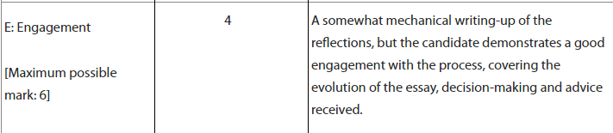

Language A: language and literature—example B
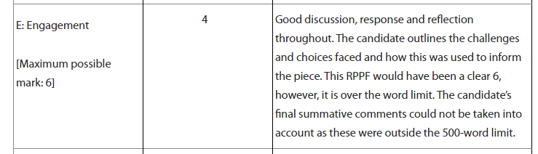

History: Example B
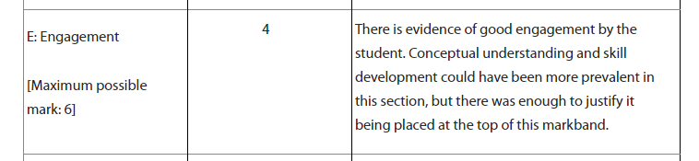

Psychology: Example A
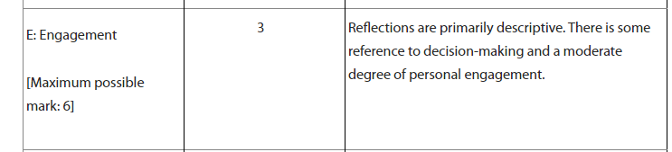

Biology: Example A
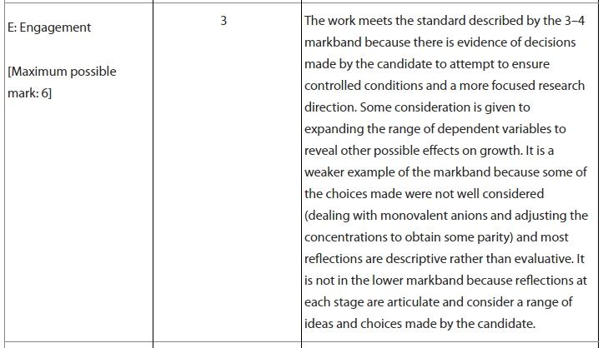

Biology: Example C
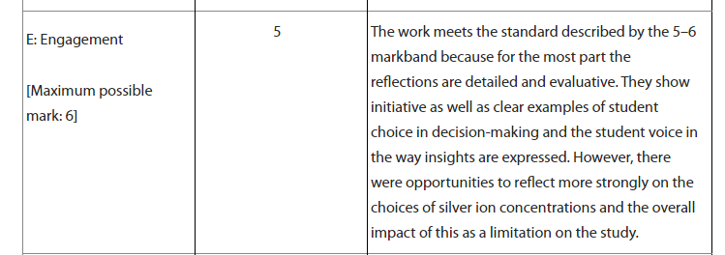

Mathematics: Example B
