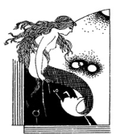 Visual Arts EE Due Dates -2020

- Conference 1: Nov. 28 – Dec. 6
  - Research Question
  - Bring books and articles to support research question and purpose.
- Conference 2: Feb. 5-16
  - Bring more books and articles.
  - Working Outline.
- Conference 3 :Mar. 19-29/Apr. 9-18
  - Annotated Bibliography.
  - Working Outline.
  - First 1000 words.
- Conference 4:May 21- June 1
  - Bibliography
  - 5 Pages of Essay
  - Table of Contents
  - List of Illustrations
- Conference 5: Sept. 24 – Oct. 5
  - All VA EE student group conference with Khan
- Conference 6: Sept. 24 - Oct. 5
  - Personal Final Conference about Rough draft
- Final Due: Nov. 29th or sooner

